# Sorting Rows by Region and Family Members

This document includes the question, the solution, and a breakdown of the code provided in the screenshot.

## Uploaded Screenshot

Below is the screenshot of the task:

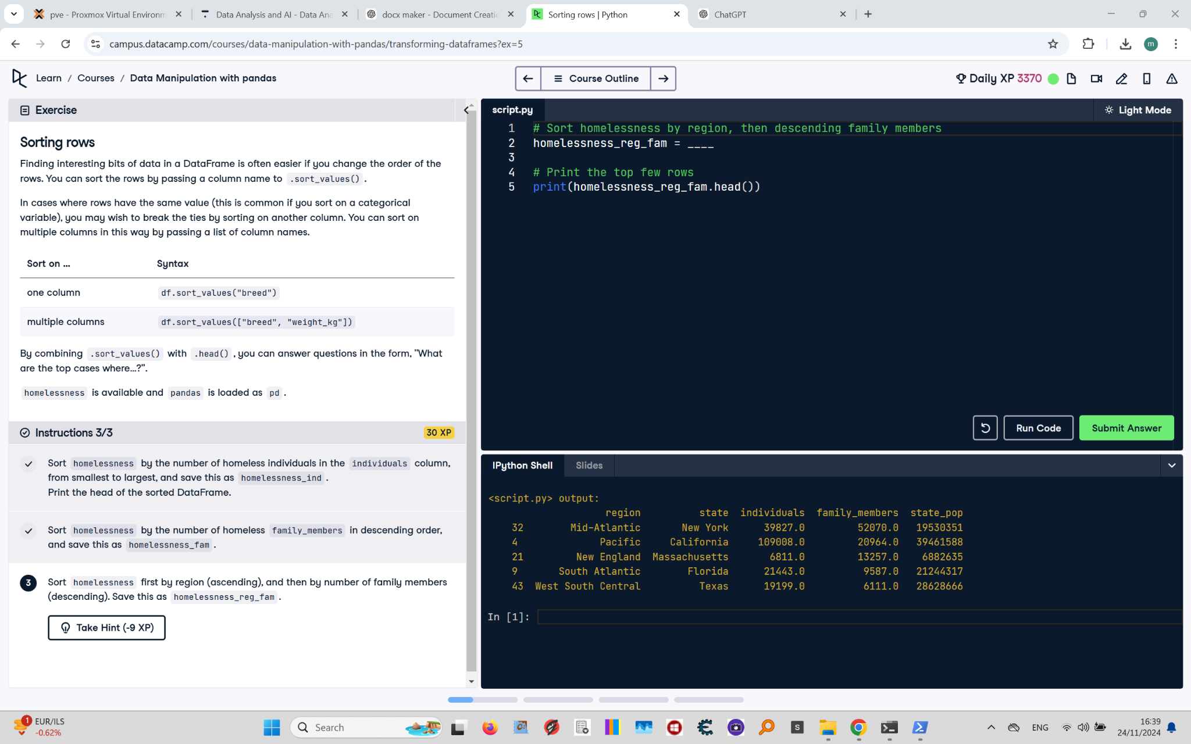

## Question

Sort the homelessness DataFrame first by region (in ascending order), then by the number of family members (in descending order). Save this as `homelessness_reg_fam`. Print the head of the sorted DataFrame.

## Answer

# Sort homelessness by region, then descending family members  
homelessness_reg_fam = homelessness.sort_values(  
 by=["region", "family_members"], ascending=[True, False]  
)  
  
# Print the top few rows  
print(homelessness_reg_fam.head())

## Code Explanation

# Explanation of the code:

1. `homelessness.sort_values(by=["region", "family_members"], ascending=[True, False])`: Sorts the `homelessness` DataFrame by two criteria:

- `region`: Sorted in ascending order.

- `family_members`: Sorted in descending order (indicated by `False`).

2. `homelessness_reg_fam`: Stores the sorted DataFrame for further use.

3. `print(homelessness_reg_fam.head())`: Displays the first five rows of the sorted DataFrame to verify the sorting.